Tuesday 23rd of September 2014
LO: To describe a setting
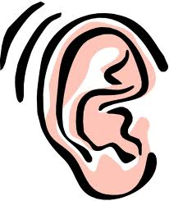 What would you hear? What can you see?
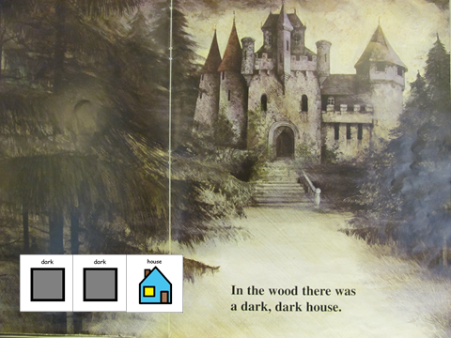 What would you smell?
____________________________________________________________________________________________________________________________________________________________________________________________________________________________________________________________________________________________________________________________

